Please attempt all the questions
- What are the two things that are required for you to snap a picture in a DSLR camera?

- Name the following shot sizes in the box provided.

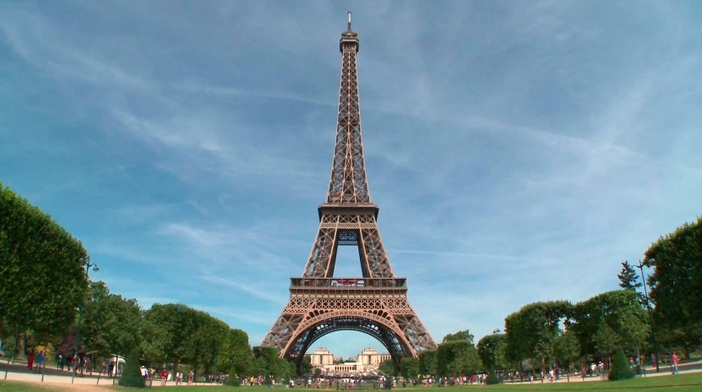

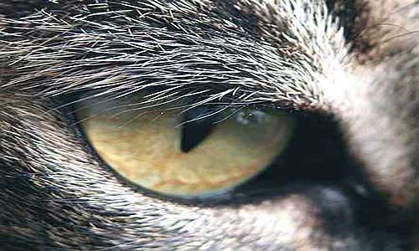

- Name the 3 pillars of photography.

- What does the term Over Exposed and Under Exposed means?

- Write the full form of these modes that can be found in a Canon DSLR camera:
- TV ___________
- P ________________
- AV __________________
- CA ___________________
- M _____________________

- Give the definition of the following:
Aperture

Shutter Speed

ISO

- Underline the following:
a) Cameras can be used in the left hand
True/False
b) Video cannot be taken using a DXLR camera
True/False
c) Editing the photos in Photoshop is also called Post Production
True/False
d) You can snap a picture without SD card because there will be a 3 seconds preview
True/False

